SVR Intuition

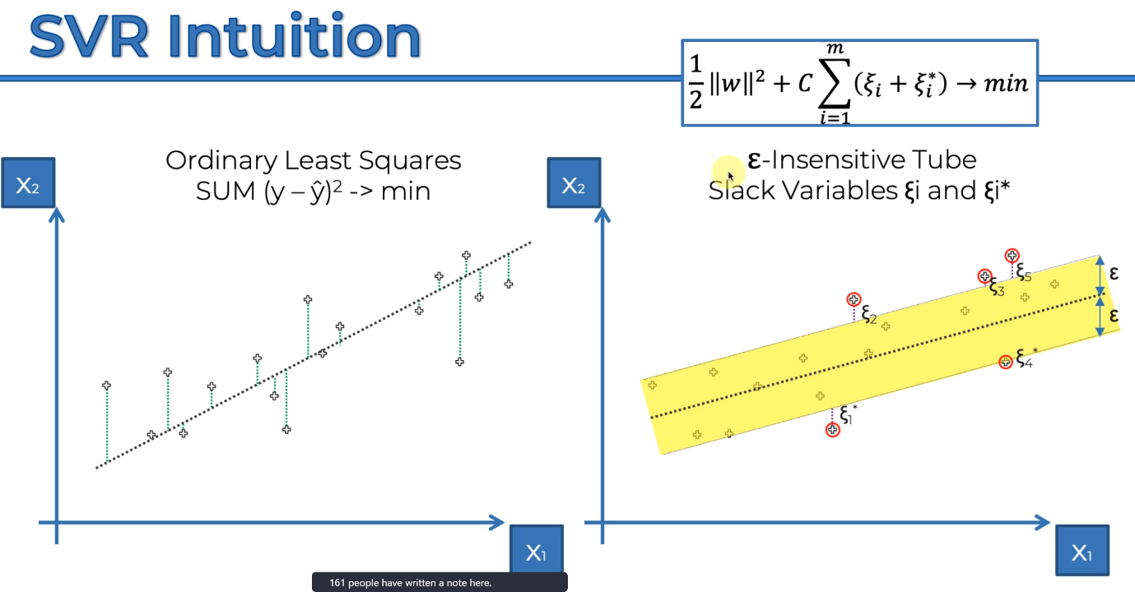Ordinary least squares

e-insensitive Tube means like marginal error. Give a little bit of buffer to our model.

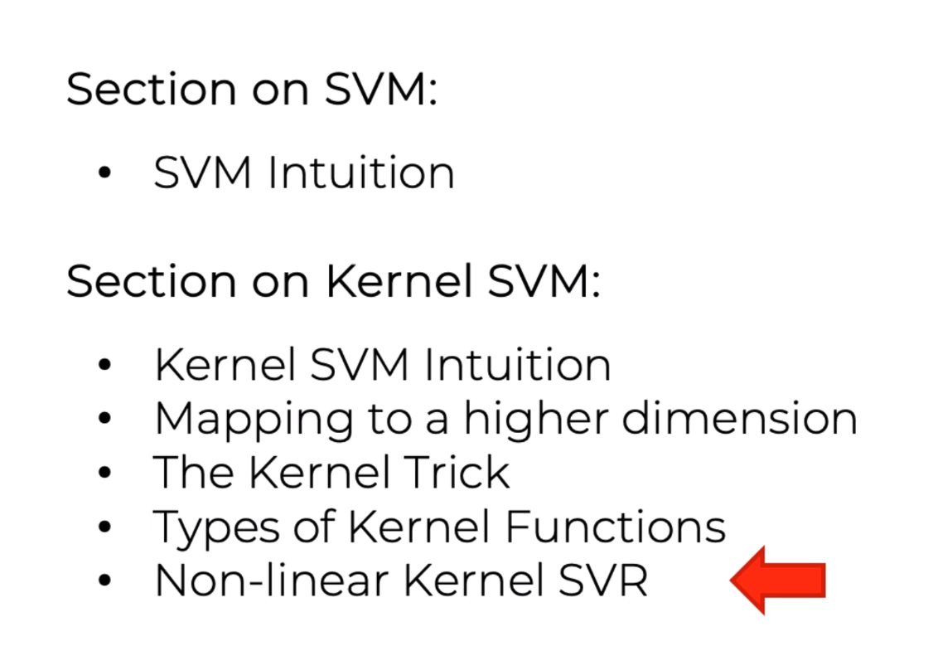<https://core.ac.uk/download/pdf/81523322.pdf>